**LAB-2**

Muhammad Bilal (021-18-0037)

1. Write a query to display EMPLOYEE_ID, FIRST_NAME, and SALARY of employees whose SALARY is less than $3000

**QUERY:** select EMPLOYEE_ID, FIRST_NAME, SALARY from employees where salary<3000;

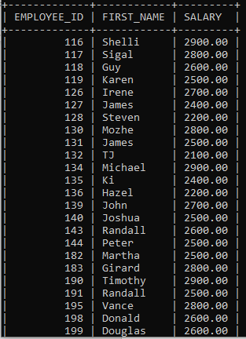

1. Write a query to display FIRST_NAME, LASTNAME of all employees whose first name starts with letter ‘A’.

QUERY: SELECT FIRST_NAME, LAST_NAME FROM EMPLOYEES WHERE FIRST_NAME LIKE 'a%';

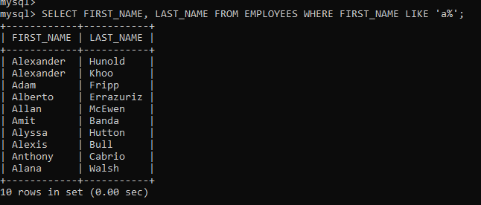

1. Write a query to display FIRST_NAME, JOB_ID, DEPARTMENT_ID of employees who are either PU_CLERK or belongs to MANAGER_ID = 114.

QUERY: SELECT FIRST_NAME, JOB_ID, DEPARTMENT_ID FROM EMPLOYEES WHERE JOB_ID="PU_CLERK" OR MANAGER_ID = "114";

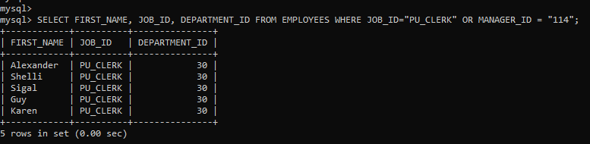

1. Write a query to display EMPLOYEE_ID, FIRST_NAME, and SALARY of employees whose salaries lies in the range of $1500 to $3000;

QUERY: SELECT EMPLOYEE_ID, FIRST_NAME, SALARY FROM EMPLOYEES WHERE SALARY BETWEEN 1500 AND 3000;

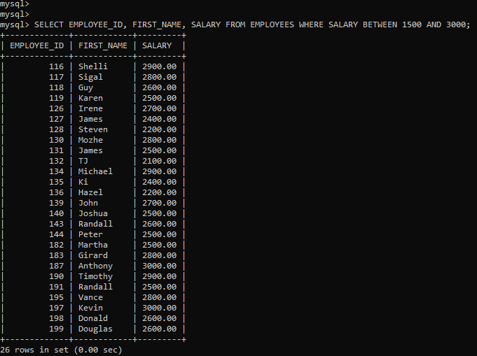

1. Write a query to display EMPLOYEE_ID, FIRST_NAME, and SALARY of employees whose commission is empty.

QUERY: SELECT EMPLOYEE_ID, FIRST_NAME, SALARY FROM EMPLOYEES WHERE COMMISSION_PCT LIKE '%'; 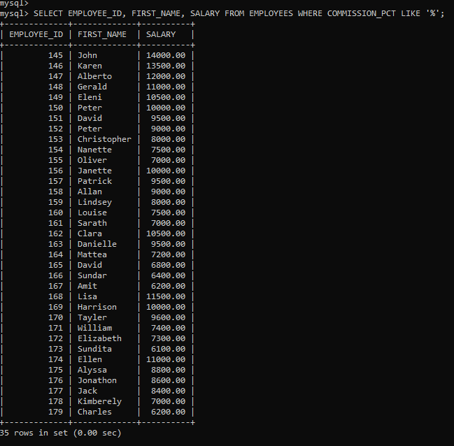

1. Write a query to display first names of all employees that end with alphabet ‘N’.

QUERY: SELECT FIRST_NAME FROM EMPLOYEES WHERE FIRST_NAME LIKE '%N';

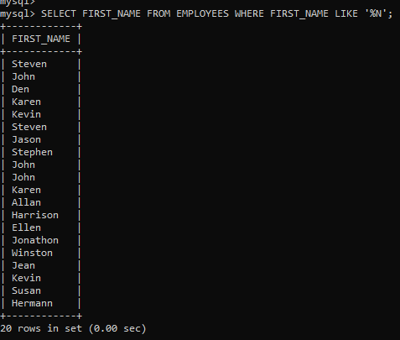

1. Write a query to display FIRST_NAME, JOB_ID, DEPARTMENT_ID of employees who are not PU_CLERK.

QUERY: SELECT FIRST_NAME, JOB_ID, DEPARTMENT_ID FROM EMPLOYEES WHERE JOB_ID <> 'PU_CLERK'; 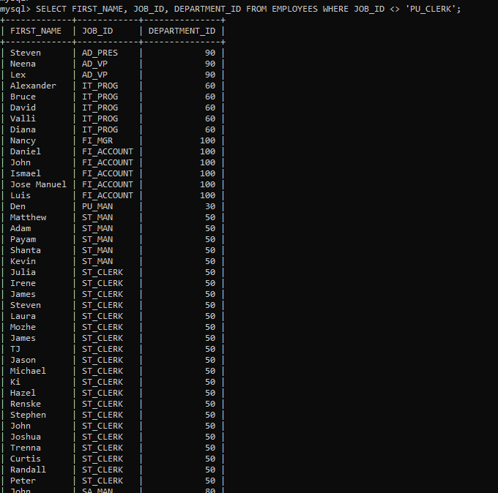

1. Write a query to display EMPLOYEE_ID, FIRST_NAME, and SALARY of those employees who do not have salaries of $3300, $3200, $2200.

QUERY: SELECT EMPLOYEE_ID, FIRST_NAME, SALARY FROM EMPLOYEES WHERE SALARY IN (3300, 3200, 2200) ; 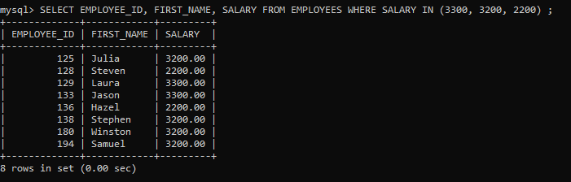

1. Write a query to display names of those employees whose first name starts with ‘A’ and ends with ‘N’.

QUERY: SELECT FIRST_NAME FROM EMPLOYEES WHERE FIRST_NAME LIKE 'A%N'; 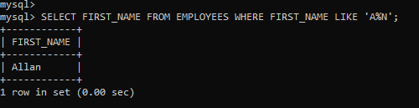

1. Write a query to display the list of employee names that have letters ‘LA’ in their names.

QUERY: SELECT FIRST_NAME FROM EMPLOYEES WHERE FIRST_NAME LIKE '%LN%'; 

1. Write a query to display the EMPLOYEE_ID, FIRST_NAME, and SALARY of employees. In that, the highest paid employee should display first and lowest paid should display last.

QUERY: SELECT EMPLOYEE_ID, FIRST_NAME, SALARY FROM EMPLOYEES ORDER BY SALARY DESC; 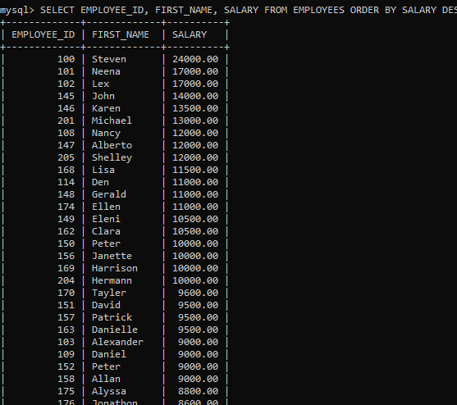

1. Write a query to display FIRST_NAME of employees that have "a" in the second position.

QUERY: SELECT FIRST_NAME FROM EMPLOYEES WHERE FIRST_NAME LIKE '_A%'; 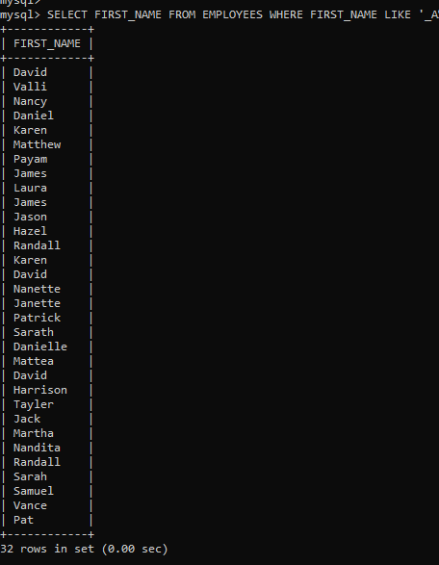

1. Write a query to display EMPLOYEE_ID, FIRST_NAME, and SALARY of employees whose salaries do not lies in the range of $1500 to $3000;

QUERY: SELECT EMPLOYEE_ID, FIRST_NAME, SALARY FROM EMPLOYEES WHERE SALARY<1500 OR SALARY>3000; 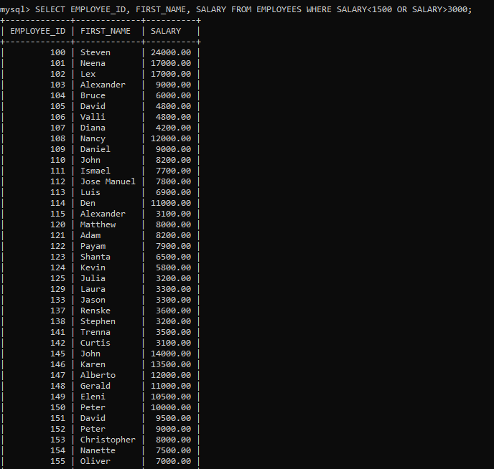

1. Write a query to display FIRST_NAME, LAST_NAME and DEPARTMENT_ID of all employees in departments 30 or 100 in ascending order.

QUERY: SELECT FIRST_NAME, LAST_NAME, DEPARTMENT_ID FROM EMPLOYEES WHERE DEPARTMENT_ID=30 OR DEPARTMENT_ID=100; 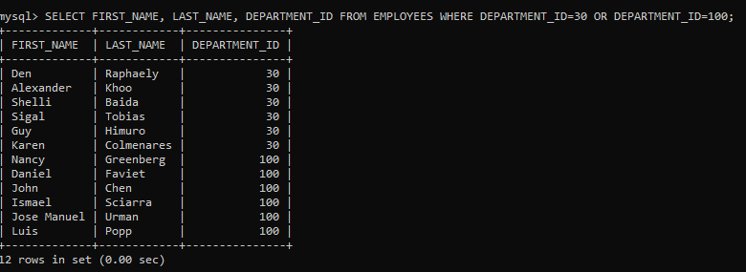

1. Write a query to display FIRST_NAME, LAST_NAME and SALARY for all employees whose salary is not in the range $10,000 through $15,000 and are in department 30 or 100.

QUERY: SELECT FIRST_NAME, LAST_NAME, SALARY FROM EMPLOYEES WHERE (SALARY < 10000 OR SALARY > 15000) AND (DEPARTMENT_ID = 30 OR DEPARTMENT_ID = 100); 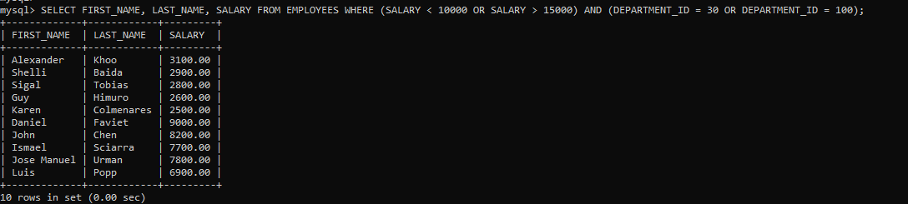

1. Write a query to display FIRST_NAME, LAST_NAME and HIRE_DATE for all employees who were hired in 1987.

QUERY: SELECT FIRST_NAME, LAST_NAME, HIRE_DATE FROM EMPLOYEES WHERE HIRE_DATE LIKE "1987%"; 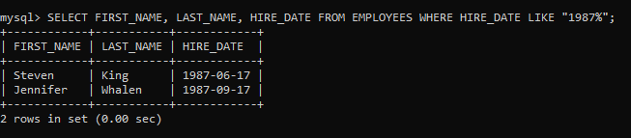

1. Write a query to display the LAST_NAME of employees whose LAST_NAME have exactly 6 characters.

QUERY: SELECT LAST_NAME FROM EMPLOYEES WHERE LAST_NAME LIKE "_____"; 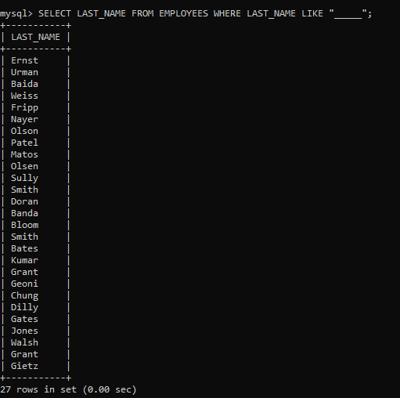

1. Write a query to display FIRST_NAME, SALARY and PF (15% of salary) of all employees.

QUERY: SELECT FIRST_NAME , SALARY , SALARY/100*15 AS PF FROM EMPLOYEES ; 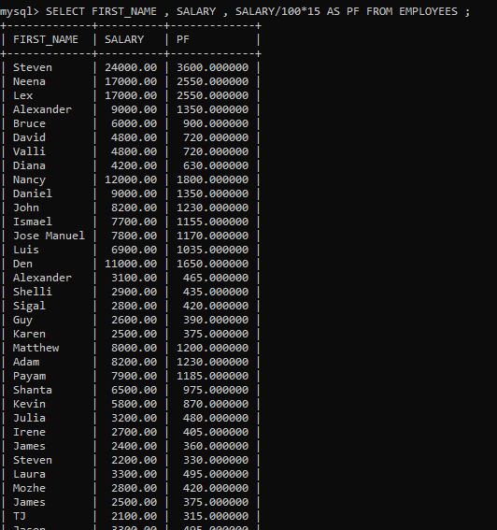

1. Write a query to display FIRST_NAME, SALARY and commission amount (% of salary) of all employees.

QUERY: SELECT FIRST_NAME , SALARY , SALARY/100 AS COMMISSION_AMOUNT FROM EMPLOYEES ; 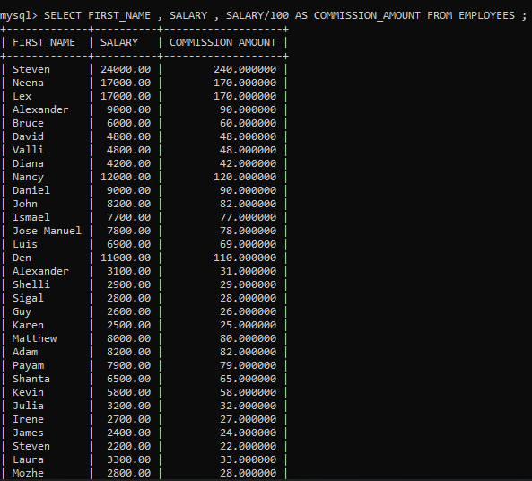

1. Write a query to display FIRST_NAME, SALARY and NET_SALARY after 500 deduction from salary of all employees;

QUERY: SELECT FIRST_NAME , SALARY , SALARY-500 AS NET_SALARY FROM EMPLOYEES ; 